Hi, I will be splitting this report into two parts, the first part will be the testing of my report and it will showcase features of the game.

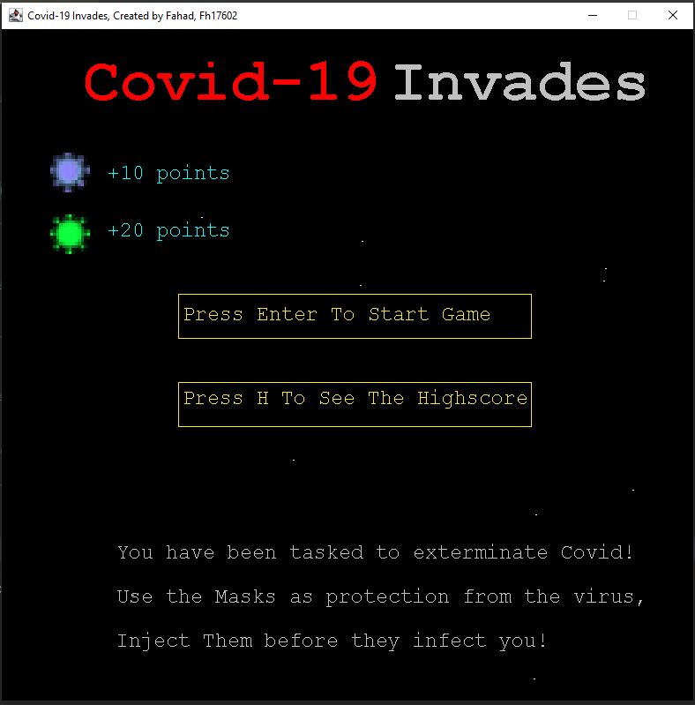

Figure 1

This is the screen that will be shown to the user when they first run the program, it is the menu, the user can navigate to the high score where it will display the top 5 scores or can go into the main game. (task a)

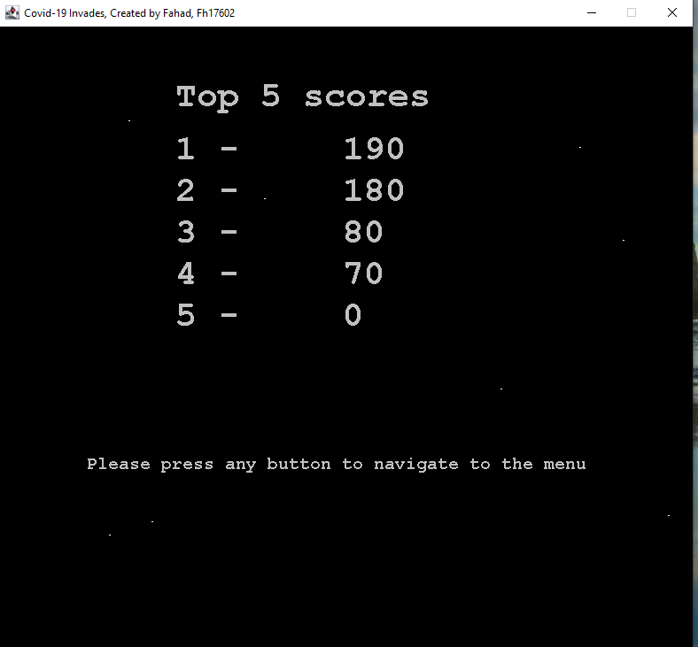

Figure 2

When pressing the high score button in the menu, it displays the top 5 scores that is specified in the assignment brief, it will update every time a person has beaten the top 5 score, so if someone was to get higher than 70 they will be higher than third position. This screen reads from a text file called high scores(task g , d)

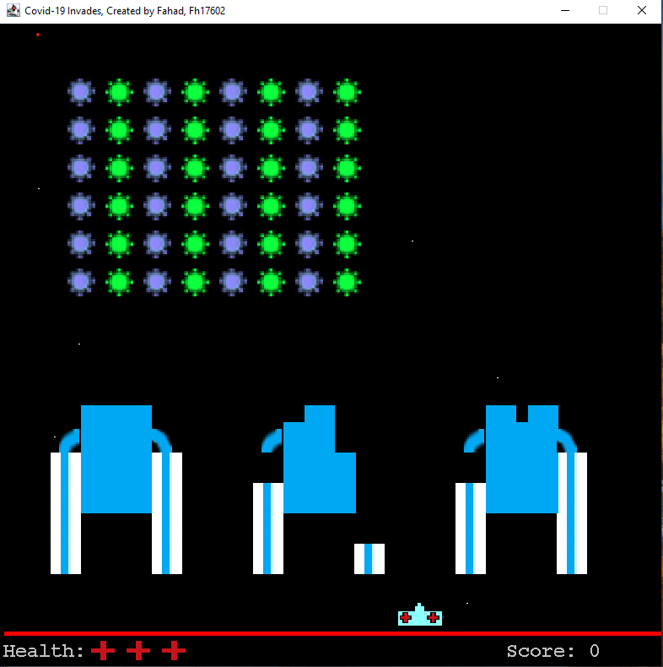

Figure 3

This is a screen snip of the game, as you can see some of the mask squares have been removed, this is due to the Covid-19 sprites shot mechanic, there is a random chance of the last strand to shoot a projectile that can hit both the user and mask squares that protect him.

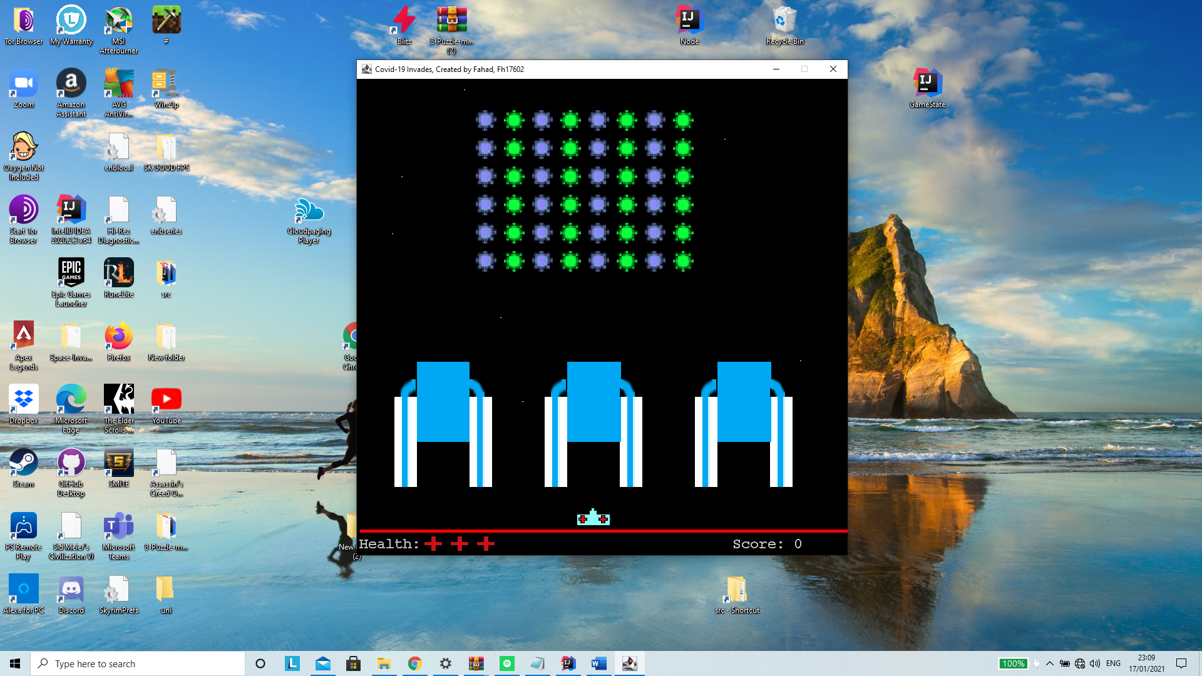

Figure 4

This is what the beginning of the game is like, the user starts off with three lives, if all the Covid-19 strands are injected/defeated the user gets another life. (task a)

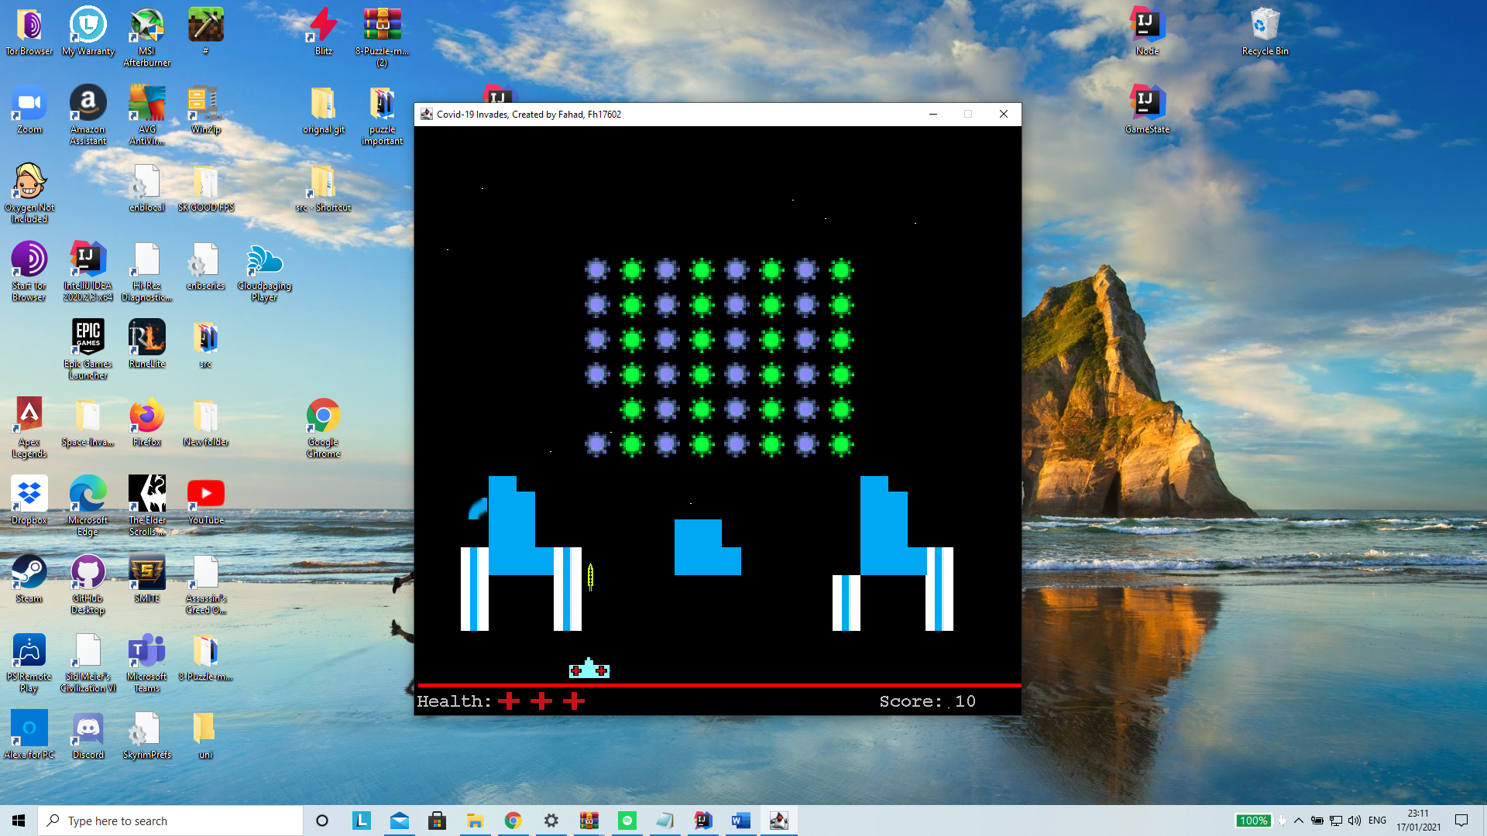

Figure 5

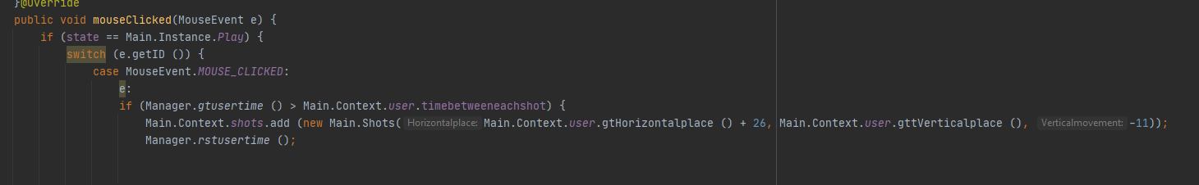

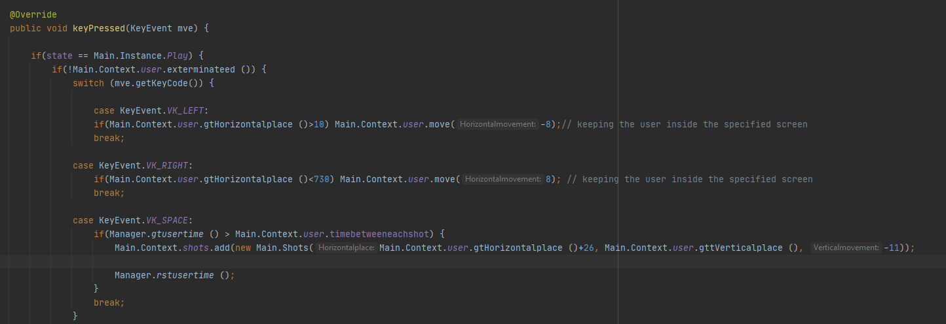

In figure 5, if the user either clicks the left mouse button or the space key it will shoot an injection that interacts with both the mask entity and the Covid-19 strands. This projectile disappears at a certain point in the screen if nothing is hit. Above there are two event handler classes, with the keyboard event class the user is able to move left or right and is also able to shoot, the mouse event handler class can only shoot. (task c).

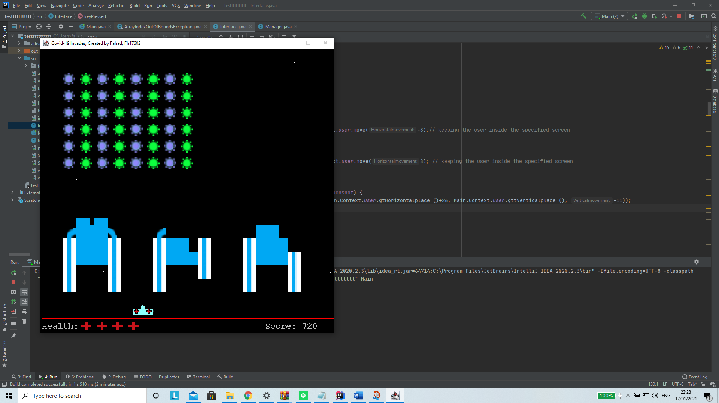

Figure 6

The user has managed to clear all the Covid-19 strands which reset the screen and spawned in more strands, the user has gained a life and the score remains.

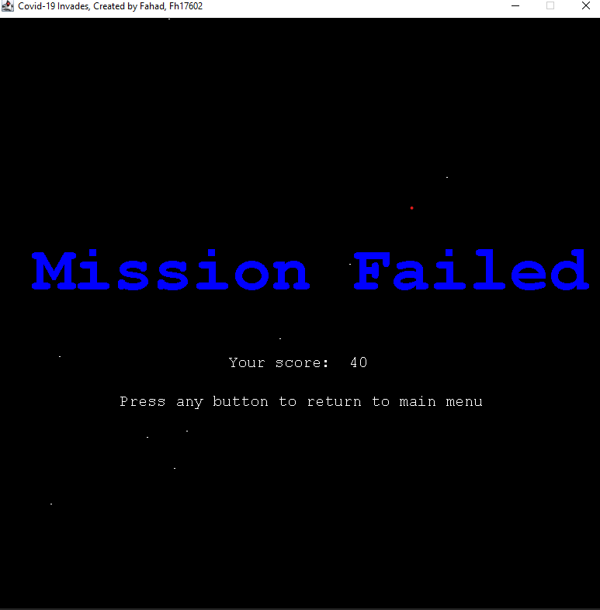

Figure 7

User has died, game indicates mission failed screen, shows score and allows user to go back to the menu interface(d)

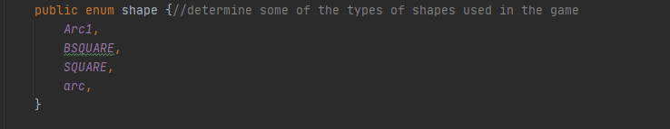

Figure 8

Shapes used to draw, the masks on the game screen.

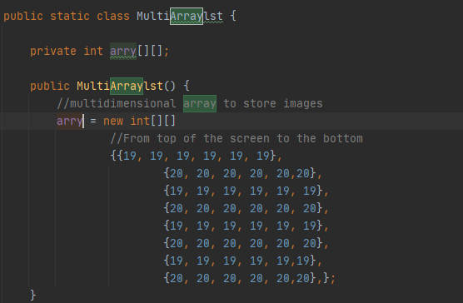

Figure 9

Using an array list to determine what image is placed where, so in this instance to determine how the Covid-19 strands are placed in the game (e.g. line of blue strands then green e.c.t.)

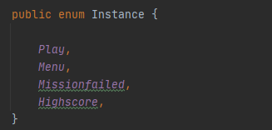

Figure 10

All the instances of the game used to help the user navigate throughout the game.(f)



Figure 11

This class is crucial to the game as it sets up a hitbox for each entity I use, so the ship will have a hitbox which will have specified parameters, these hit boxes interact with one another, so a shot from the users ship will interact with the covid-19 strand, if the shot intersects the strand hitbox values, the program will then remove the specified strand from the screen.



An example of an hitbox.

Some of the benefits of using MYSQL with JBDC to upload the scoring systems would be:

Security, MYSQL tends to be much safer than using a text file to store the scores in, if the game that is designs gets a lot of popularity, there will be an element of restricting the amount that a user can access, with MYSQL the admin can ensure integrity to the scoring system of the game and prevent hackers/ people trying to access unauthorised data to change aspects of the scoring system. If someone reaches a significant high score there needs to be an element of protecting it from someone trying to change this unethically, so implementing MYSQL for security will benefit most game creators in the long run.

Quicker/ efficient query searches and fast retrieval of data,

With the use of JBDC, you will be able to store much more than 5 top scores and search through them much more efficiently, if your game is on a larger scale and has a relatively decent player base, you will want to have quick access to the data they provide, this will be done much more efficiently on MYSQL than it will on a text file.